Q1.
(a) Figure 1 shows the oscilloscope trace an alternating current (a.c.) electricity supply produces.
Figure 1
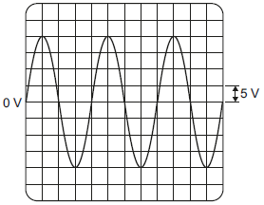
One vertical division on the oscilloscope screen represents 5 volts.
Calculate the peak potential difference of the electricity supply.
___________________________________________________________________
Peak potential difference = _________________________ V
(1)
(b) Use the correct answer from the box to complete the sentence.

40 | 50 | 60
In the UK, the frequency of the a.c. mains electricity supply is ______ hertz.
(1)
(c) Figure 2 shows how two lamps may be connected in series or in parallel to the 230 volt mains electricity supply.
Figure 2
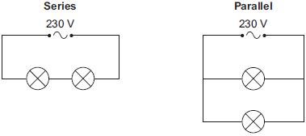
(i) Calculate the potential difference across each lamp when the lamps are connected in series.
The lamps are identical.
______________________________________________________________
Potential difference when in series = ___________ V
(1)
(ii) What is the potential difference across each lamp when the lamps are connected in parallel?
Tick (✔) one box.

115 V | 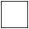 | 230 V |  | 460 V
(1)
(iii) Give one advantage of connecting the lamps in parallel instead of in series.
______________________________________________________________
______________________________________________________________
(1)
(d) Figure 3 shows the light fitting used to connect a filament light bulb to the mains electricity supply.
Figure 3
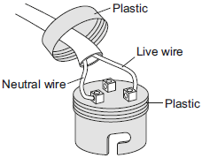
The light fitting does not have an earth wire connected.
Explain why the light fitting is safe to use.
___________________________________________________________________
___________________________________________________________________
___________________________________________________________________
___________________________________________________________________
(2)
(e) A fuse can be used to protect an electrical circuit.
Name a different device that can also be used to protect an electrical circuit.
___________________________________________________________________
(1)
(Total 8 marks)
Q2.
The diagram shows an electric circuit used in a dolls’ house.
The switches are 2-way switches; this means that each switch has a connecting wire that can be in one of two positions.
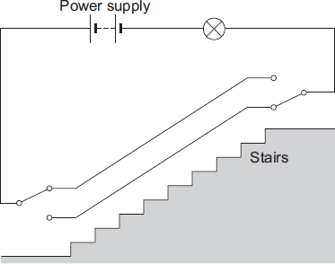
(a) (i) With the connecting wire in each switch in the position shown in the diagram, the lamp is off. Why?
______________________________________________________________
______________________________________________________________
(1)
(ii) When switched on, the lamp has a resistance of 18 Ω and draws a current of 0.5 A from the power supply.
Use the equation in the box to calculate the potential difference of the power supply used in the circuit.

potential difference = current × resistance
Show clearly how you work out your answer.
______________________________________________________________
______________________________________________________________
Potential difference = _________________________ V
(2)
(iii) A second, identical lamp is added to the circuit. The two lamps are joined in series.
Calculate the total resistance of the two lamps.
______________________________________________________________
Total resistance = _________________________ Ω
(1)
(b) This type of circuit is also used in real houses. One of the switches is at the top of the stairs, and the other switch is at the bottom of the stairs.
What is the advantage of using this circuit to switch a lamp on or off, rather than using a more simple circuit that has only one switch?
___________________________________________________________________
___________________________________________________________________
(1)
(c) The diagram shows an old type of metal lamp fitting.
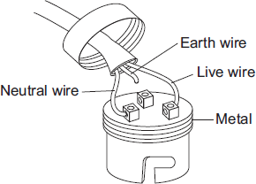
The cable has been connected to the lamp fitting in a way that makes the lamp fitting unsafe.
(i) What is the possible risk to someone touching the lamp fitting while the lamp is switched on?
______________________________________________________________
______________________________________________________________
(1)
(ii) What should be done to make this lamp fitting safe to use?
______________________________________________________________
______________________________________________________________
(1)
(Total 7 marks)
Q3.
(a) The diagram shows the traces produced on an oscilloscope when it is connected across different electricity supplies.
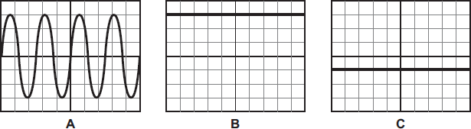
Which of the traces could have been produced by the mains electricity supply?
___________________________________________________________________
Give a reason for your answer.
___________________________________________________________________
___________________________________________________________________
(2)
(b) The picture shows two adaptors being used to plug five electrical appliances into the same socket.
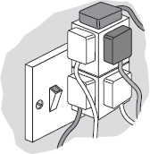
Explain why it is dangerous to have all five appliances switched on and working at the same time.
___________________________________________________________________
___________________________________________________________________
___________________________________________________________________
___________________________________________________________________
(2)
(Total 4 marks)
Q4.
Many electrical appliances are connected to the mains supply using a three-core cable and a three-pin plug.
(a) Use the correct answer from the box to complete the sentence.

charge | energy | power
Electric current is the rate of flow of _______________________________ .
(1)
(b) The diagram shows a three-pin plug connected to a three-core cable.
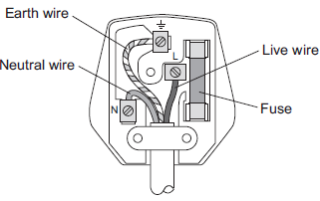
(i) The three wires of the three-core cable have different coloured coverings.
State the colour of the covering of the neutral wire.
______________________________________________________________
(1)
(ii) Which two parts of the plug shown above protect the wiring of a circuit?
Tick () two boxes.

Tick ()
Earth wire
Fuse
Live wire
Neutral wire
(2)
(c) Some electrical appliances are connected to the mains supply using a two-core cable and a three-pin plug. Appliances that are double insulated do not require all three wires.
(i) What does ‘double insulated’ mean?
______________________________________________________________
______________________________________________________________
(1)
(ii) State which of the three wires is not required.
______________________________________________________________
(1)
(d) (i) An electrical appliance is connected to a 20 V supply.
The current in the appliance is 3 A.
Calculate the power of the appliance.
______________________________________________________________
______________________________________________________________
Power = _________________________ W
(2)
(ii) Another electrical appliance is connected to a 20 V supply.
The appliance transfers 300 J of energy.
Calculate the charge.
Give the unit.
______________________________________________________________
______________________________________________________________
Charge = _________________________
Unit _____________
(3)
(Total 11 marks)
Q5.
Figure 1 shows a radio. The radio can be powered by connecting the two-core cable to the mains electricity supply.
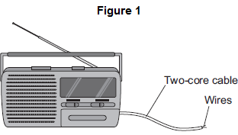
(a) (i) What must be fitted to the cable before it can be connected to the mains electricity supply?
______________________________________________________________
(1)
(ii) There are only two wires inside the cable.
What are the names of the two wires inside the cable?
Tick () one box.

Earth and live | 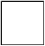
Earth and neutral
Live and neutral
(1)
(iii) Use the correct answer from the box to complete the sentence.

double | extra | fully
It is safe to connect the radio to the mains electricity supply using a two-core
cable because the radio is ____________________________ insulated.
(1)
(b) The radio can also be powered by a battery.
What type of current does a battery supply?
Tick () one box.

Alternating current (a.c.) only
Direct current (d.c.) only
Both a.c. and d.c.
(1)
(c) Figure 2 shows a fuse and a circuit breaker.
Fuses and circuit breakers are able to disconnect and switch off circuits.
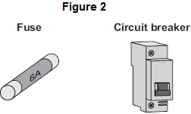
(i) Use the correct answer from the box to complete the sentence.

earth | live | neutral
A fuse or a circuit breaker is connected to the ____________________ wire in a circuit.
(1)
(ii) What happens to cause a fuse or circuit breaker to disconnect a circuit?
______________________________________________________________
______________________________________________________________
(1)
(iii) Suggest two advantages of using a circuit breaker to disconnect a circuit compared with using a fuse.
1. ____________________________________________________________
______________________________________________________________
2. ____________________________________________________________
______________________________________________________________
(2)
(Total 8 marks)
Q6.
(a) An adaptor can be used to connect up to four appliances in parallel to one 230 V mains socket. The adaptor is fitted with a 13 A fuse. The table gives a list of appliances and the current they draw from a mains socket.
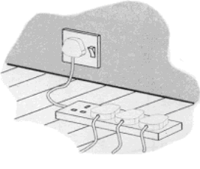

Appliance | Current
computer | 1 A
hairdryer | 4 A
heater | 8 A
iron | 6 A
television | 2 A
(i) What current will flow to the adaptor when the television, computer and hairdryer are plugged into the adaptor?
______________________________________________________________
Current = _________________ A
(1)
(ii) Write down the equation which links current, electrical power and voltage.
______________________________________________________________
(1)
(iii) Calculate the electrical power used when the television, computer and hairdryer are plugged into the adaptor. Show clearly how you work out your answer and give the unit.
______________________________________________________________
______________________________________________________________
______________________________________________________________
Electrical power = ___________________
(2)
(iv) What would happen to the fuse if the heater is also plugged into the adaptor?
Give a reason for your answer.
______________________________________________________________
______________________________________________________________
(2)
(b) The diagram shows two of the appliances.
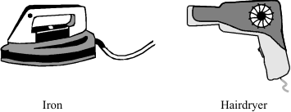
(i) For safety reasons, it is important that the iron has an earth wire connected to its outer metal case. Explain why.
______________________________________________________________
______________________________________________________________
______________________________________________________________
______________________________________________________________
(2)
(ii) The hairdryer does not have an earth wire. It is safe to use because it is double insulated. Explain what the term double insulated means.
______________________________________________________________
______________________________________________________________
______________________________________________________________
______________________________________________________________
(2)
(Total 10 marks)
Q7.
If a fault develops in an electrical circuit, the current may become too great. The circuit needs to be protected by being disconnected.
A fuse or a circuit breaker may be used to protect the circuit.
One type of circuit breaker is a Residual Current Circuit Breaker (RCCB).
(a) (i) Use the correct answer from the box to complete the sentence.

earth | live | neutral
A fuse is connected in the ______________________ wire.
(1)
(ii) Use the correct answer from the box to complete the sentence.

are bigger | are cheaper | react faster
RCCBs are sometimes preferred to fuses because they ________________ .
(1)
(iii) RCCBs operate by detecting a difference in the current between two wires.
Use the correct answer from the box to complete the sentence.

earth and live | earth and neutral | live and neutral
The two wires are the _______________________________________ wires.
(1)
(b) An RCCB contains an iron rocker and a coil.
A student investigated how the force of attraction, between a coil and an iron rocker, varies with the current in the coil.
She supported a coil vertically and connected it in an electrical circuit, part of which is shown in the figure below .
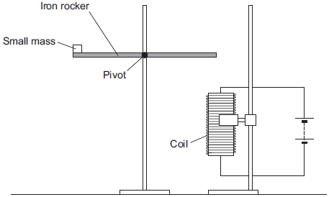
She put a small mass on the end of the rocker and increased the current in the coil until the rocker balanced. She repeated the procedure for different masses.
Some of her results are shown in the table below.

Mass  in grams | Current needed for the  rocker to balance in  amps
5 | 0.5
10 | 1.0
15 | 1.5
20 | 2.0
(i) State two extra components that must have been included in the circuit in the figure above to allow the data in the above table to be collected.
Give reasons for your answers.
______________________________________________________________
______________________________________________________________
______________________________________________________________
______________________________________________________________
______________________________________________________________
______________________________________________________________
______________________________________________________________
______________________________________________________________
(4)
(ii) A teacher said that the values of current were too high to be safe.
Suggest two changes that would allow lower values of current to be used in this investigation.
Change 1 ______________________________________________________
______________________________________________________________
Change 2 ______________________________________________________
______________________________________________________________
(2)
(Total 9 marks)
Q8.
Carefully read the following extract from a safety leaflet. Then answer the questions.

An RCD adaptor is an automatic safety switch. It should be used when there is a particular risk of electric shock. For example, it is recommended that it is used with an electric lawnmower.
Inside one make of RCD is an electromagnet that holds the switch closed so that the RCD is switched on. An electronic circuit in the RCD monitors the difference between the current in the live wire and the current in the neutral wire.
If something goes wrong and this difference is greater than 30 milliamps then the RCD will trip (= switch off) within 40 milliseconds.
(a) Suggest two reasons why there is a particular risk of an electric shock when using an electric lawnmower.
1. _________________________________________________________________
___________________________________________________________________
2. _________________________________________________________________
___________________________________________________________________
(2)
(b) Why will there be a difference between the current in the live wire and the current in the neutral wire if something goes wrong?
___________________________________________________________________
___________________________________________________________________
(1)
(c) (i) Use the words charge, current and time to write an equation which shows the relationship between them.
______________________________________________________________
(1)
(ii) Calculate how much charge flows when a current of 30 milliamps passes for 40 milliseconds.
Clearly show how you get to your answer and give the unit.
______________________________________________________________
______________________________________________________________
Charge = ___________________________
(3)
(Total 7 marks)
Q9.
The diagram shows the structure of a cable. The cable is part of an undersoil heating circuit inside a large greenhouse.
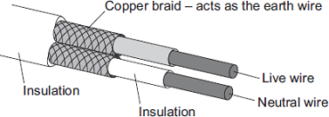
(a) The cable is connected to the mains electricity supply through a residual current circuit breaker. If the cable is accidentally cut the circuit breaker automatically switches the circuit off.
(i) What is the frequency of the mains electricity supply in the UK?
______________________________________________________________
(1)
(ii) What happens, as the cable is cut, to cause the circuit breaker to switch the circuit off?
______________________________________________________________
______________________________________________________________
______________________________________________________________
______________________________________________________________
(2)
(iii) A circuit can also be switched off by the action of a fuse.
Give one advantage of using a circuit breaker to switch off a circuit rather than a fuse.
______________________________________________________________
______________________________________________________________
(1)
(b) The 230 volt mains electricity supply causes a current of 11 amps to flow through the cable.
(i) Calculate the amount of charge that flows through the cable when the cable is switched on for 2 hours and give the unit.
______________________________________________________________
______________________________________________________________
______________________________________________________________
Charge = _________________________
(3)
(ii) Calculate the energy transferred from the cable to the soil in 2 hours.
______________________________________________________________
______________________________________________________________
Energy transferred =_________________________ J
(2)
(c) The heating circuit includes a thermistor. The thermistor is buried in the soil and acts as a thermostat to control the increase in the temperature of the soil.
Describe how an increase in the temperature of the soil affects the thermistor.
___________________________________________________________________
___________________________________________________________________
___________________________________________________________________
___________________________________________________________________
(2)
(Total 11 marks)

Mark schemes
Q1.
(a) 20
1
(b) 50
1
(c) (i) 115
1
(ii) 230
1
(iii) if one goes out the other still works
or
brighter
accept power (output) is greater
can be switched on/off independently is insufficient
1
(d) the outside/casing is plastic
there is plastic around the wires is insufficient
it is plastic is insufficient
1
and plastic is an insulator
an answer the light fitting is double insulated gains both marks
1
(e) (residual current) circuit breaker
accept RCCB
accept RCBO
accept RCCD
accept RCB
accept miniature circuit breaker / MCB
trip switch is insufficient
breaker is insufficient
do not accept earth wire
1
[8]
Q2.
(a) (i) circuit not complete
accept circuit is broken
accept switch / s are open / off
1
(ii) 9
allow 1 mark for correct substitution, ie 0.5 × 18 provided no subsequent step shown
2
(iii) 36
1
(b) can be switched on / off from top or bottom of stairs
1
(c) (i) (electric) shock
accept fitting becomes live
accept answers giving a possible consequence of electric shock, eg death
1
(ii) connect the earth wire
1
[7]
Q3.
(a) A
only scores if A chosen
1
it is alternating / a.c.
accept because B and C are d.c.
or
it changes direction/p.d.
accept voltage for p.d.
it goes up and down is insufficient
it is constantly changing is insufficient
an answer B and/or C with the reason because it is direct current/d.c scores 1 mark
1
(b) too much current (through socket)
accept electricity for current
accept too much power
accept socket/circuit overloaded
do not accept voltage/p.d for current
1
wiring / socket gets hot
accept melts for gets hot
accept risk of fire
risk of fire in appliances is insufficient
ignore reference to sparking
overloaded plugs and plugs getting hot or fuses melting is insufficient
1
[4]
Q4.
(a) charge
1
(b) (i) blue
1
(ii) earth wire
1
fuse
1
(c) (i) case is non-metal / non-conducting / plastic / insulator
must refer to case / outside of appliance
do not accept plastic coating / covering
1
(ii) earth (wire)
1
(d) (i) 60 (W)
P = 3 × 20 gains 1 mark
provided no subsequent step shown
2
(ii) 15
300 = 20 × Q
or
20 = 300 / Q gains 1 mark
2
C / coulombs
must clearly be upper case C accept J / V or As
1
[11]
Q5.
(a) (i) (3-pin) plug
do not accept plug socket
1
(ii) live and neutral
1
(iii) double
1
(b) direct current (d.c.) only
1
(c) (i) live
1
(ii) too great a current flows
accept a surge of current
accept too great a power
accept an electrical fault
do not accept voltage / energy / electricity too high
1
(iii) can be reset
accept does not need replacing
1
(disconnects circuit) faster
cheaper is insufficient
does not melt is insufficient
quicker to fix / replace is insufficient
1
[8]
Q6.
(a) (i) 7
1
(ii) (electrical) power = voltage x current
accept P = V × I (correct standard symbol)
accept watts = volts x amps
accept a correct rearrangement
accept 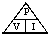 if subsequent use of 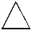 is correct
1
(iii) 1610
or their (a)(i) × 230
1.61 kW = 2 marks
do not accept 7 × 240
2
watts
accept watt
accept W
accept .J/s
(iv) melts
accept burns out
accept blows
accept breaks
do not accept stops working
do not accept burns
2
current greater than 13(A)
or current exceeds fuse rating or current 15(A)
do not accept too much current
unless qualified
(b) (i) if live wire touches case
accept if case becomes live
accept metal for case
2
current flows to earth or ground
or fuse melts or stops iron becoming live
accept electricity flows to earth
do not accept - you will get a shock
accept with no earth (wire) you would or could get a shock for 1mark
(ii) (outer) case is made of insulator
accept outside is plastic
accept outside is not made of metal or conductor
cable is (also) insulated
accept wires for cable
do not accept it has two layers of insulation without explanation
do not credit answers in terms of heat
2
[10]
Q7.
(a) (i) live
1
(ii) react faster
1
(iii) live and neutral
1
(b) (i) ammeter
1
to measure current
accept to measure amps
1
plus any one from:
• variable resistor (1)
to vary current (1)
accept variable power supply
accept change or control
• switch (1)
to stop apparatus getting hot / protect battery
or
to reset equipment (1)
• fuse (1)
to break circuit if current is too big (1)
2
(ii) any two from:
• use smaller mass(es)
• move mass closer to pivot
• reduce gap between coil and rocker
• more turns (on coil)coil / loop
• iron core in coil
accept use smaller weight(s)
2
[9]
Q8.
(a) any two from
(risk of) cutting (through the) cable
accept cutting the wire
grass may be wet
or it may rain
wires may be loose (because cable experiences a lot of movement)
accept cable may be loose
(risk of) touching exposed part(s)
2
(b) some current will go through (the rest of) the lawnmower / the user / to earth
do not credit any reference to the electromagnet
1
(c) (i) charge = current × time
or any transposed version
accept Q = I × t
or any transposed version
accept C = A × s
or coulombs = amperes × seconds
or any transposed version
or 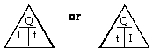
but only if subsequently used correctly
1
(ii) EITHER
1200 microcoulombs / μC
or 1.2 millicoulombs / mC
or 0.0012 coulombs /C
3
OR
correct arithmetic
either
converting milliamps to amps
and milliseconds to seconds
or correct multiplication
unit given as coulombs /C
or millicoulombs / mC
or microcoulombs / μC
example : charge = 30 × 40 = 1200 millicoulombs should be credited with 2 marks
1
[7]

Q9.
(a) (i) 50(Hz)
ignore any unit given
1
(ii) any two from:
• (some) current flows to Earth
accept ground for Earth
• current flows through copper braid
accept current flows through the earth wire
accept electricity for current in either the first or second marking point but not both
• RCCB detects difference between current in live and neutral wire
2
(iii) can be reset
accept does not need replacing
or
faster acting
accept switches circuit off faster
1
(b) (i) 79 200
allow 1 mark for correct substitution, ie 11 =
an answer 22 gains 1 mark
2
coulombs / C
do not accept c
1
(ii) 18 216 000
accept for 2 marks 18 216 kJ or 18.216 MJ
or
230 × their (b)(i) correctly calculated
allow 1 mark for correct substitution, ie 230 × their (b)(i) or
allow 1 mark for power calculated as 2530(W)
2
(c) increases temperature of thermistor
1
changes resistance (of thermistor)
do not accept increases resistance (of thermistor)
an answer decreases resistance (of thermistor) gains 2 marks
1
[11]

